**Semester 2 (Units 3 and 4) Examination, 2018**

**Question/Answer Booklet**

**MATHEMATICS APPLICATIONS**

**Section One: Calculator-free**

Student Name/Number: ______________________________________________

Teacher Name: ______________________________________________

**Time allowed for this section**

Reading time before commencing work: five minutes

Working time: fifty minutes

**Materials required/recommended for this section**

***To be provided by the supervisor:***

This Question/Answer Booklet

Formula Sheet

***To be provided by the candidate:***

Standard items: pens (blue/black preferred), pencils (including coloured), sharpener,

correction fluid/tape, eraser, ruler, highlighters

Special items: nil

**Important note to candidates**

No other items may be taken into the examination room. It is **your** responsibility to ensure that you do not have any unauthorised material. If you have any unauthorised material with you, hand it to the supervisor **before** reading any further.

**Structure of this paper**

|  |  |  |  |  |  |
| --- | --- | --- | --- | --- | --- |
| Section | Number of questions available | Number of questions to be answered | Working time (minutes) | Marks available | Percentage of exam |
| Section One: Calculator-free | 6 | 6 | 50 | 50 | 35 |
| Section Two: Calculator-assumed | 10 | 10 | 100 | 100 | 65 |
|  | | | | | 100 |

**Instructions to candidates**

1. The rules for the conduct of School exams are detailed in the *College assessment policy*. Sitting this examination implies that you agree to abide by these rules.
2. Write your answers in this Question/Answer Booklet.

3. You must be careful to confine your answers to the specific question asked and to follow any instructions that are specified to a particular question.

4. Supplementary pages for the use of planning/continuing your answer to a question have been provided at the end of this Question/Answer booklet. If you use these pages to continue an answer, indicate at the original answer where the answer is continued, i.e. give the page number.

5. Show all working clearly.Your working should be in sufficient detail to allow your answers to be checked readily and for marks to be awarded for reasoning. Incorrect answers given without supporting reasoning cannot be allocated any marks. For any question or part question worth more than two marks, valid working or justification is required to receive full marks. If you repeat any question, ensure that you cancel the answer you do not wish to have marked.

6. It is recommended that you do not use pencil, except in diagrams.

7. The Formula Sheet is not to be handed in with your Question/Answer Booklet.

**Section One: Calculator-free 35% (50 Marks)**

This section has **six** (**6)** questions. Answer **all** questions. Write your answers in the spaces provided.

Supplementary pages for the use of planning/continuing your answer to a question have been provided at the end of this Question/Answer booklet. If you use these pages to continue an answer, indicate at the original answer where the answer is continued, i.e. give the page number.

Working time: 50 minutes.

**Question 1 (8 marks)**

Consider the following recurrence relation:



(a) Display the first six terms of this sequence on the axes below. Label the axes clearly.

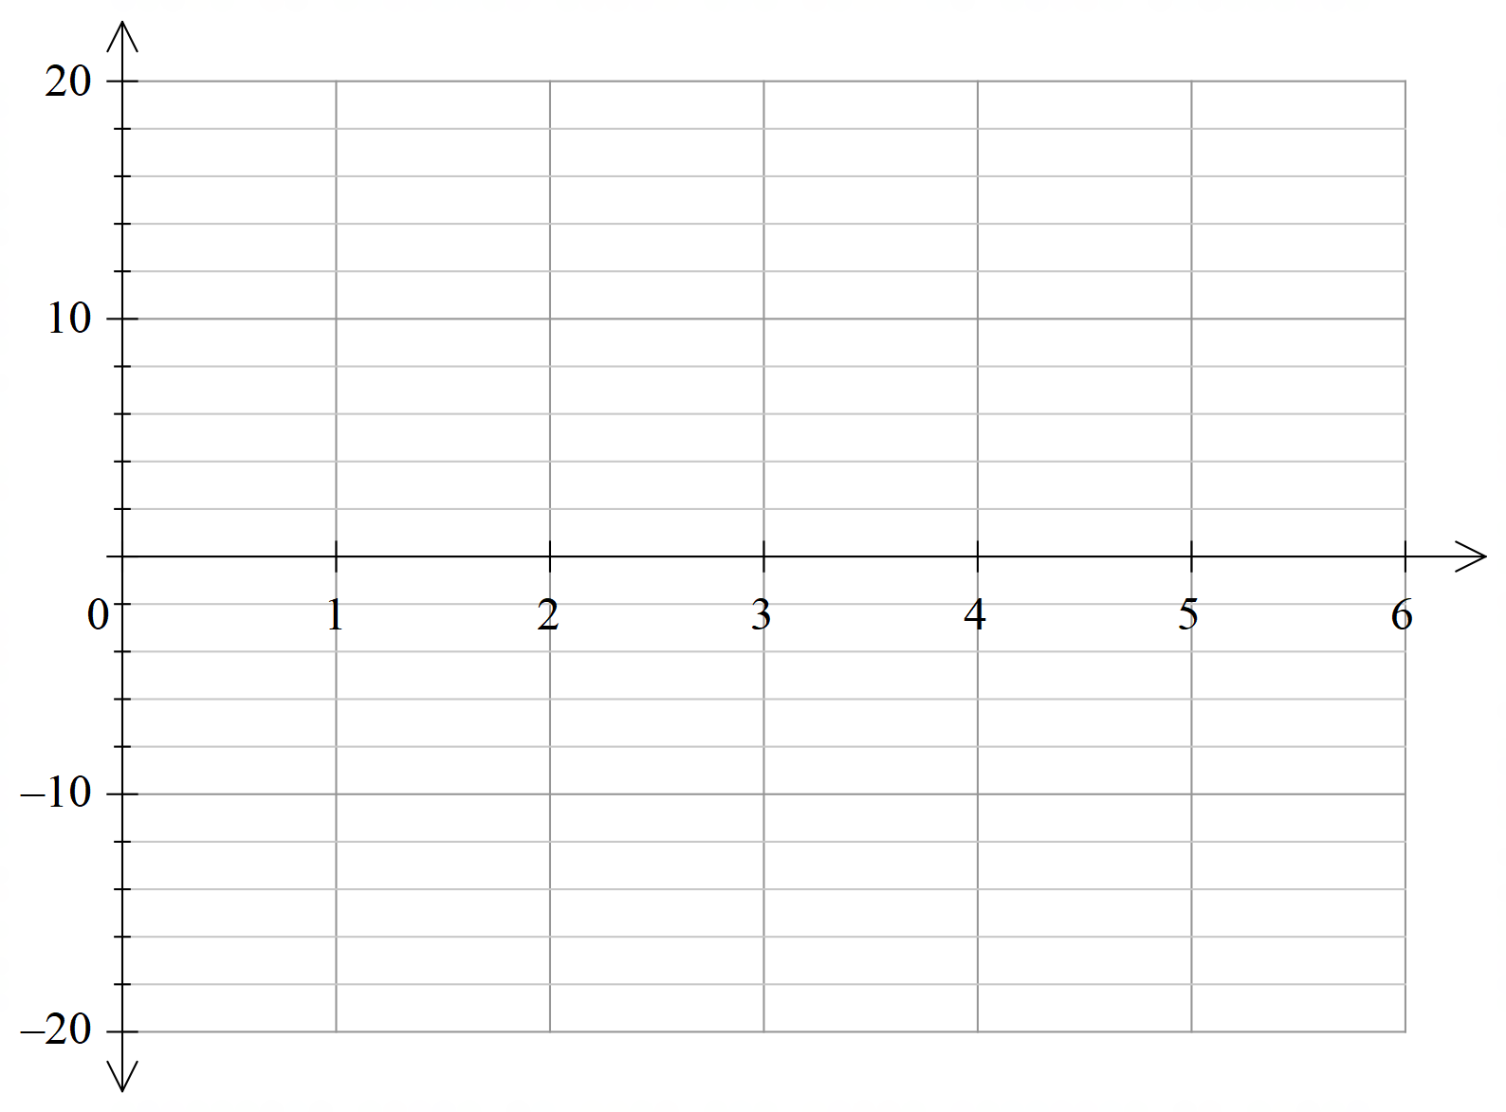 (3 marks)



(b) Deduce a rule for the *n*th term of this sequence. (2 marks)

(c) Determine the value of the first term of the sequence which is less –400. (3 marks)

**Question 2 (10 marks)**

Each morning Bert leaves the depot (D) to deliver milk to cafés in his area. He visits each café once and has produced a map showing the number of cafés, the roads linking them and the lengths (kilometres) of these roads. His map is represented by the graph below.

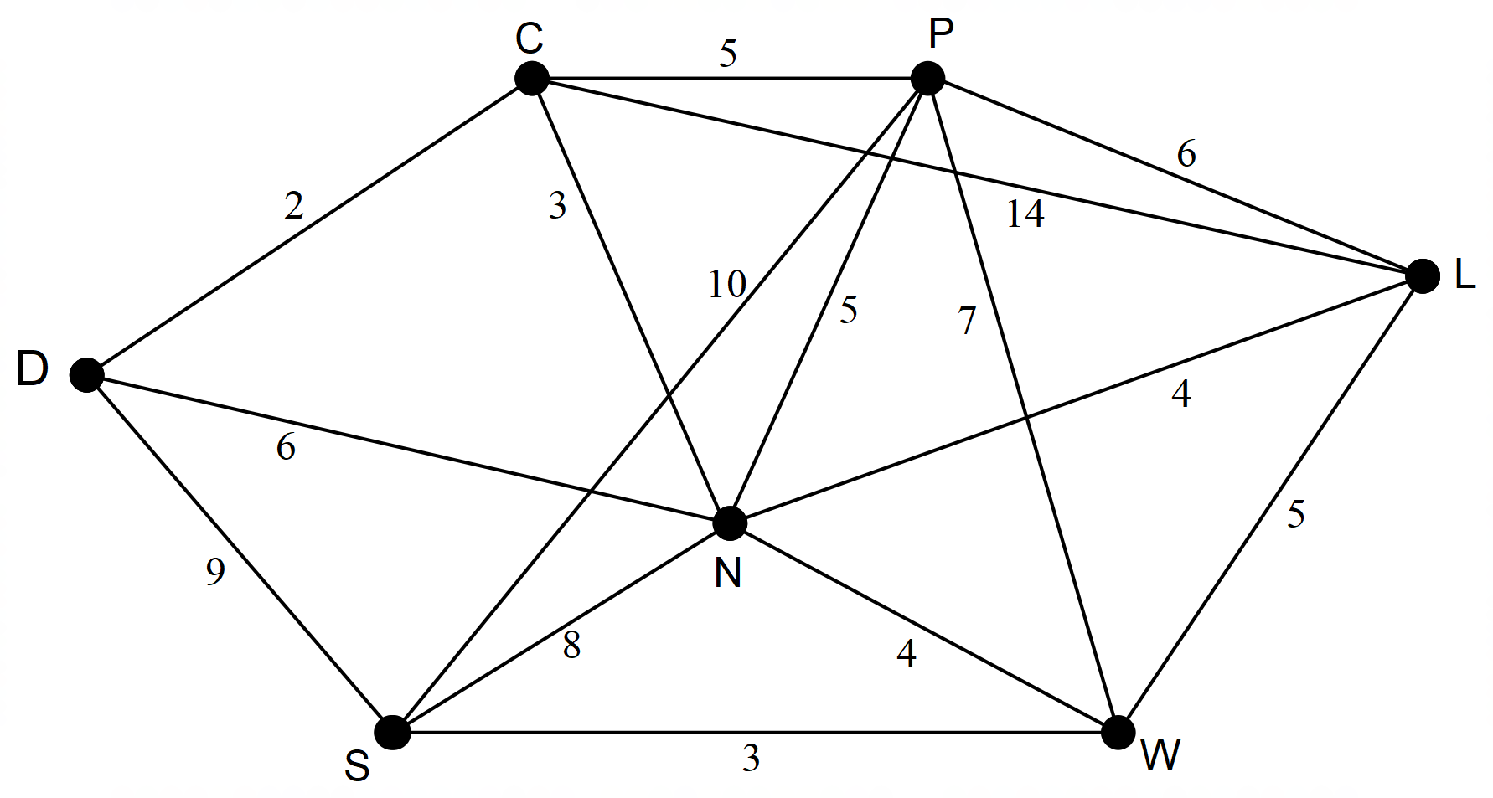

(a) (i) Identify the number of vertices on this graph. (1 mark)

(ii) Identify the number of edges on this graph. (1 mark)

(b) Is the graph planar? Justify your answer. (2 marks)

(c) This graph is described as a simple and connected graph. Explain why this description can be applied. (2 marks)

(d) Bert wants to identify a route that would allow him to deliver to each café without going over any road more than once. Identify a route that he could take starting and ending at the depot and visiting the café at C first. How long is his route? (2 marks)

(e) What is the name used to describe the route where Bert visits every café, starting and ending at the depot and not repeating any roads? (1 mark)

(f) Describe another route for Bert where the first two cafés visited are N and P in that order. The route also starts and ends at the depot and each café is visited just once with no roads repeated. (1 mark)

**Question 3 (10 marks)**

The local tennis club is holding a junior tournament and Janet is scheduling members to help in the canteen. The table below shows the availability of five different members.

|  |  |  |  |  |  |
| --- | --- | --- | --- | --- | --- |
|  | Wednesday | Thursday | Friday | Saturday | Sunday |
| Barb | 0 | 3 | 3 | 3 | 0 |
| Jed | 3 | 0 | 4 | 0 | 3 |
| Ron | 4 | 4 | 4 | 0 | 0 |
| Mark | 2 | 0 | 0 | 0 | 3 |
| Lucy | 4 | 1 | 0 | 2 | 0 |

(a) Complete the diagram below to draw a weighted bipartite graph where each edge represents the hours available for the member on the different days. (3 marks)

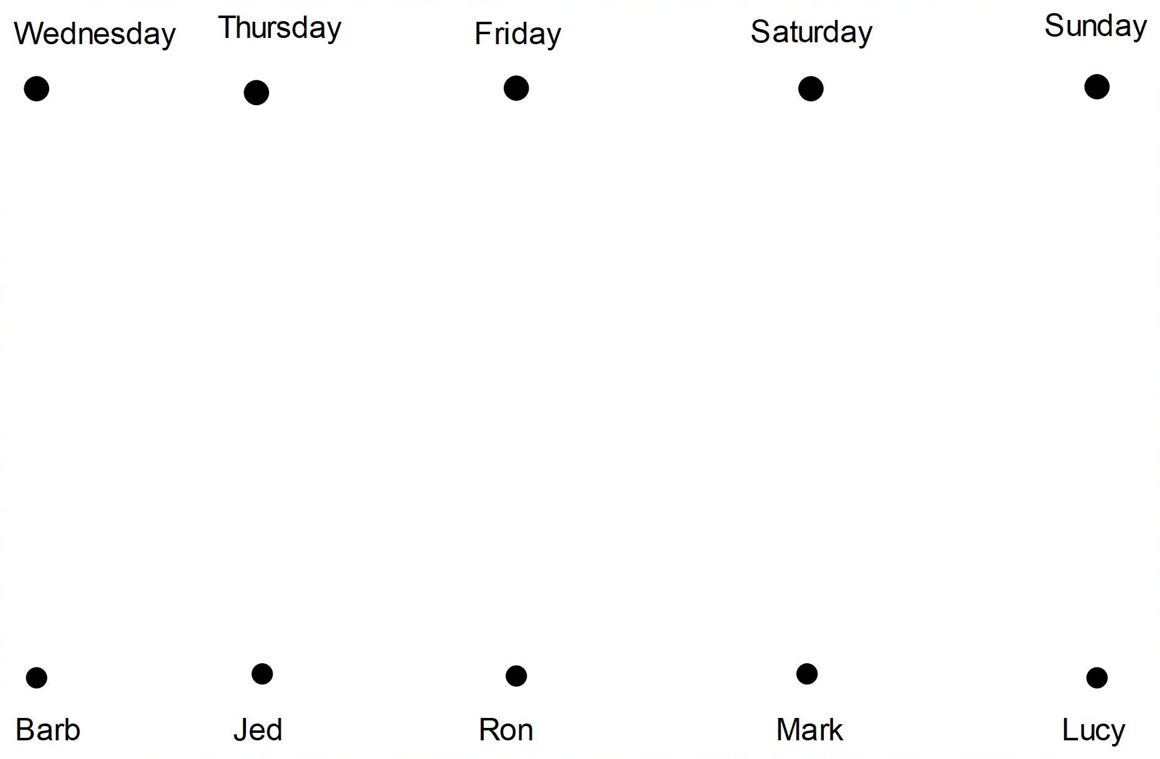

(b) Create a labelled matrix to display the information presented in the table. (1 mark)

(c) Janet only wants to have one person in the canteen each day but also wants to have the maximum number of hours possible. How can these five members be scheduled when each person helps in the canteen on a different day and the maximum number of hours is reached? What is this maximum number of hours? (3 marks)

(d) Janet has also created a table showing the number of cupcakes that other members can bring in on each of the days from Wednesday to Saturday. A different person will provide the cupcakes each day.

|  |  |  |  |  |
| --- | --- | --- | --- | --- |
|  | Wednesday | Thursday | Friday | Saturday |
| Rachel | 20 | 20 | 15 | 30 |
| Nick | 15 | 25 | 10 | 20 |
| Penny | 20 | 25 | 30 | 15 |
| Sue | 30 | 25 | 15 | 20 |

Use the Hungarian algorithm to show that for the maximum number of cakes the best days for each person are as follows:

Rachel on Saturday, Nick on Thursday, Penny on Friday and Sue on Wednesday

(3 marks)

.

**Question 4 (12 marks)**

The WYN investment company claims that the members’ balances grow at an average of 6% per annum. The graph below uses this rate of growth to show the likely growth of Fred’s balance over the next 15 years when he does not make any further contributions to the account.

(a) Determine the recurrence relation that models the growth of this investment.

(3 marks)

(b) June has invested $8 000 in the GRO investment company and her predicted rate of growth each year is 8%. At that rate her investment will be valued at approximately 300% of the her starting value after 15 years.

(i) Determine the expected value of June’s investment after 15 years. (1 mark)

(ii) Deduce a rule for the *nth* term for June’s investment. (2 marks)

The diagram below is a different graph of Fred’s investment where the annual interest has not changed but the interest has been calculated and added to the account monthly.

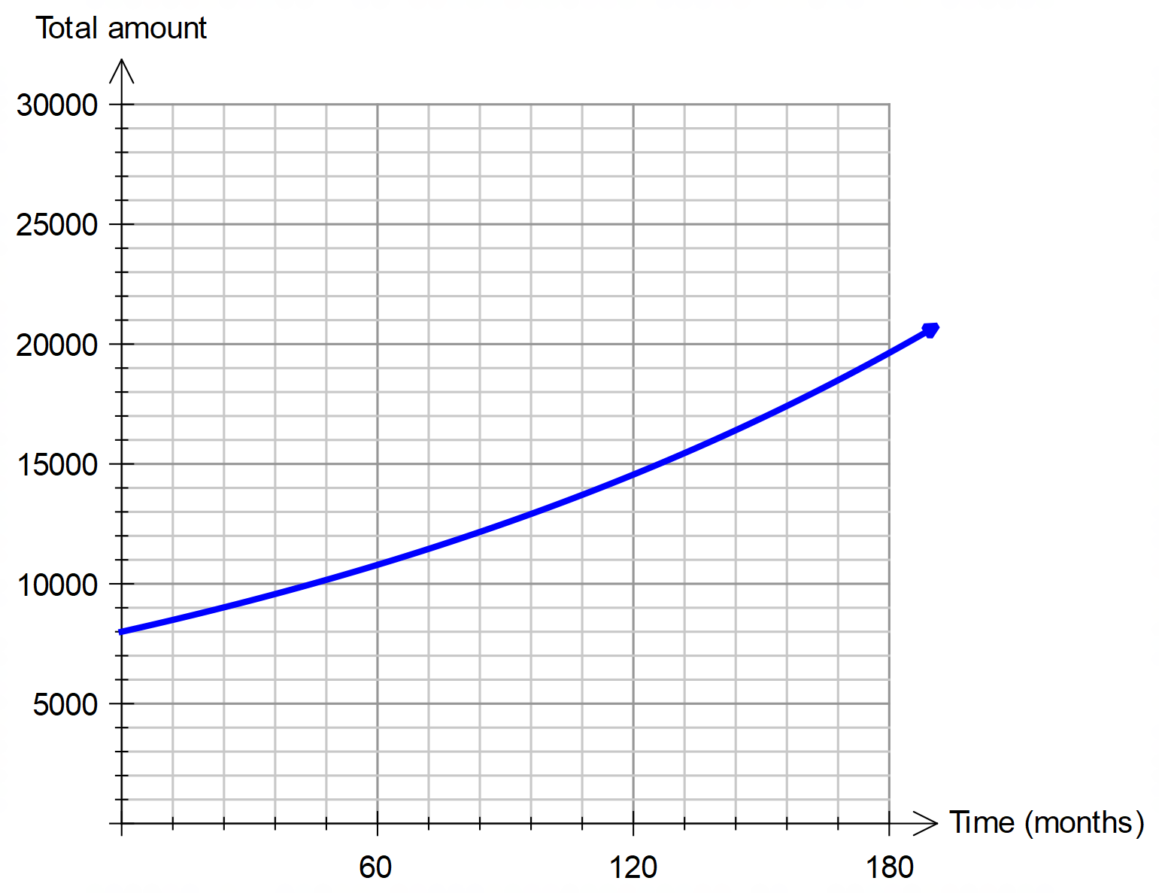

(c) What is the monthly rate of interest used for this investment? (1 mark)

(d) Use the two graphs to estimate the difference in the final value of Fred’s investments when the interest is determined monthly instead of annually. (2 marks)

(e) Draw on the grid on this page a similar type of graph to show a possible growth in June’s investment if her interest is calculated and added to the account monthly instead of annually. (3 marks)

**Question 5 (5 marks)**

Workers in a delivery company were asked which of three sports they preferred to watch on television. The results are given in the table below.

|  |  |  |  |
| --- | --- | --- | --- |
|  | **Preferred sport** | | |
| **Area where worker located** | Football | Cricket | Netball |
| Office | 4 | 16 | 5 |
| Grounds | 2 | 6 | 2 |
| Deliveries | 12 | 20 | 8 |

(a) Complete the table below to show the row percentages for the table above. (2 marks)

|  |  |  |  |
| --- | --- | --- | --- |
|  | **Percentages** | | |
| **Preferred sport** | | |
| **Area where worker located** | Football | Cricket | Netball |
| Office |  |  |  |
| Grounds | 20 | 60 | 20 |
| Deliveries |  |  |  |

(b) Identify the response variable. (1 mark)

(c) Describe one association between the two variables and explain your reasoning. Use data from the table to support your explanation. (2 marks)

**Question 6 (5 marks)**

A regional shire needs to upgrade roads between towns to provide routes for trucks carrying heavy loads. Upgrading roads is to be minimised and will be done to ensure all towns are connected. On the graph below the nodes represent the towns and the edges represent the roads connecting these towns. The distances (km) between towns are given on the graph.

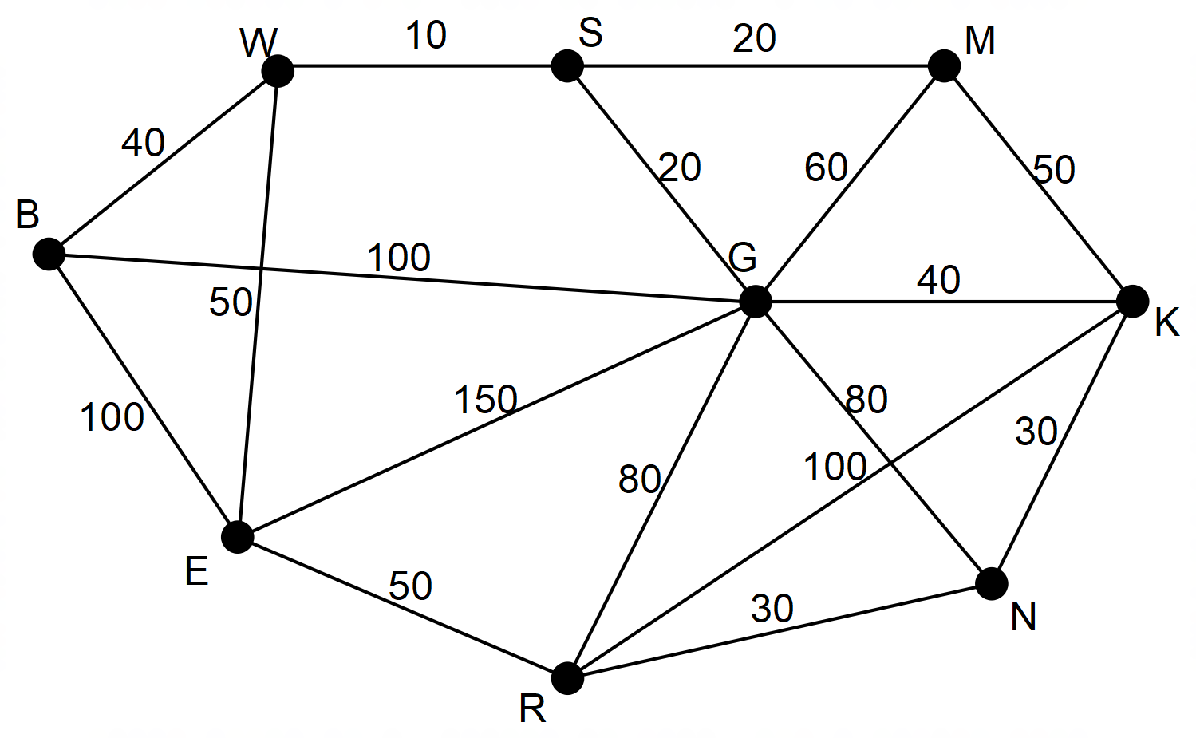

(a) Determine the length of minimum spanning tree for the upgrade of the roads and show this minimum spanning tree on the graph. (3 marks)

(b) The shire engineer wants the road between towns G and B to be upgraded. With the cost of improving the roads estimated at $1 000 000 per kilometre, how will this condition alter the minimum spanning tree and the total minimum cost of upgrading the connections between the towns. (2 marks)

**End of Questions**

Additional working space

Question number: __________________

© MAWA, 2018

This examination is Copyright but may be freely used within the school that purchases this licence.

* The items that are contained in this examination are to be used solely in the school for which they are purchased.
* They are not to be shared in any manner with a school which has not purchased their own licence.
* The items and the solutions/marking keys are to be kept confidentially and not copied or made available to anyone who is not a teacher at the school. Teachers may give feedback to students in the form of showing them how the work is marked but students are not to retain a copy of the paper or marking guide until the agreed release date stipulated in the purchasing agreement/licence.

*Published by The Mathematical Association of WA*

*12 Cobbler Place, MIRRABOOKA 6…*

**Acknowledgements**